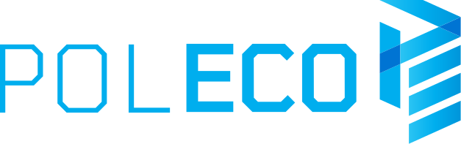

Press information Poznań, 7 February 2020

POLECO, a platform for business, knowledge and trends

A comprehensive range of solutions for environmental protection and sustainable development, conferences, meetings with experts, international character, as well as a new feature, the B2B meeting zone - these are just some of the aspects of the POLECO trade fair to be held from 21 to 23 October in Poznań.

The POLECO International Trade Fair for Environmental Protection is the largest and most important trade fair in Central and Eastern Europe focused on the latest environmental technologies. For over thirty years POLECO has attracted thousands of people interested in various aspects of environmental protection, sustainable development and municipal management to the MTP grounds. POLECO features presentations of the latest programmes and legal regulations, new system solutions as well as discussions on the development of the industry. It is in Poznań that the representatives of business, politics and science discuss the most troubling problems of this sector. A comprehensive offer presented by exhibitors from Poland and abroad is a review of the latest ecological trends and technological novelties for companies related to the industry, but also for various branches of industry and companies taking into account environmental aspects in their activities.

B2B meetings
B2B meetings, which are a quick and effective method of searching for business partners, will be a new feature of this year's POLECO. A specially designed space will be used for direct meetings of contractors with representatives of manufacturers, distributors and suppliers of solutions for environmental protection. They also enable the establishment of business contacts between interested parties. B2B meetings facilitate the exchange and flow of information, allow to create a positive image of the company, as well as build and maintain long-term business relations. They also have a significant impact on increasing the number of contractors from Poland and abroad.

Green Solutions
POLECO provides a presentation of solutions tailored to companies from various branches of industry. Apart from a comprehensive offering in the field of environmental protection, sustainable development, municipal technology, water and sewage management, POLECO is also a place to present the latest solutions for the smart city, renewable energy sources and energy-saving technologies, which enable effective energy management. In addition, it is a place for people looking for devices and systems for maintaining cleanliness in urban spaces and municipalities.

Professional visitors
The POLECO trade fair is the most important event for representatives of legislative institutions, local governments, representatives of business, science and education who are directly involved in the environmental protection industry, municipal economy and sustainable development. The trade fair is visited by the representatives of various enterprises such as: municipal management, waste management, power, heating and water supply, as well as maintenance of urban greenery. The fair is attended by managers of cooperatives, housing communities and public buildings interested in introducing energy-efficient and green solutions.

Complementary events
The fact that the POLECO trade fair is an important meeting place for experts is also evidenced by numerous conferences and trainings. This year will also focus on some of the key issues in the industry. Among others, a programme conference of the Ministry of Climate, the Urban Development Forum and conferences on Fire Protection at landfills, Extended Responsibility of Producers, Closed Circuit Management in the Packaging Industry and the Energy and Recycling Forum. The 2019 edition of the POLECO fair featured over 50 conferences, debates and panels participated in by experts in the field.

Eco-Trends powered by POLECO
Eco-Trends - an environmental event bringing together representatives of the government, local governments, non-governmental organisations (NGOs), start-ups, large socially responsible brands, enthusiasts of the idea of sustainable development and all social groups - will be held simultaneously with the POLECO trade fair. The aim of the event is to promote pro-ecological attitudes in business and everyday life.

POLECO International Trade Fair for Environmental Protection, 21 to 23 October in Poznań, Międzynarodowe Targi Poznańskie
www.poleco.pl

